Company logo | Manufacturing SOP | Doc. No. | SOP1
Company logo | SOP NAME | Date | 10/10/2025
Company logo | SOP NAME | Revision No. | 01
Purpose:
To outline the procedure for safely and correctly installing an air conditioner in a caravan.
Procedure:  - Step 1: Inspect the roof for correct installation procedure and clean the surface using a rag.  - Step 2: Mark the mounting points on the roof for the brackets and drill holes for the bracket. Make sure not to damage any wires or insulation.  - Step 3: Secure the mounting brackets using Tek screws and bolts using a torque wrench to 10Nm (Recommended Spec).  - Step 4: Lift and place the air con unit on the roof and secure it to the brackets using the provided bolts.  - Step 5: Apply SMP 50 silicone sealant around the base of the air con to prevent any leakage.  - Step 6: Wipe out any extra silicone residue and check for the seals to ensure they are tight and smooth  - Step 7: Connect the air conditioner wires to the electrical systems and test the connection.  - Step 8: Turn on the air conditioner to check if it is working properly. |  | Photos:  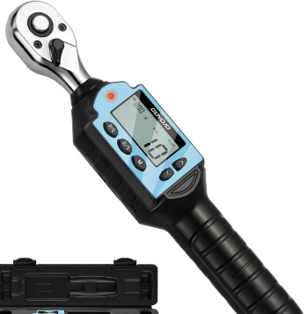  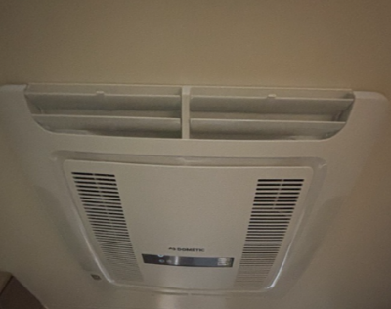
Reference Document (if any):
- Air conditioner installation manual
Roles and Responsibilities:
Role:  Production Operator (Roof section) | Responsibilities:  Ensure the assembly steps are followed precisely, inspect parts for defects, and document any discrepancies.
Required Tools and Equipment:  - Power tools  - Sealants (SMP 50)  - Mounting brackets  - Ladder  - Silicon gun  - Torque wrench | PPE:  - Safety glass  - Ear plug  - Safety gloves  - Steel caped boot

